Section 4: UX Journey Map
Section 4.1 User Role Overview
The NPO e-commerce platform is used by two principal user categories. To explore, purchase, and track artisanal products, the User or Buyer uses either the native Android application or the responsive web application. The NPO Director/Admin utilizes the web-based administration portal to manage customers' purchases, products, and inventory. The following journey maps describe each user's objectives, interactions, and user experience considerations throughout their experience.
Section 4.2 Supporter / Buyer UX Journey Map
The Supporter/Buyer UX journey describes the whole experience of someone purchasing handcrafted goods using the NPO's user-friendly website or specialized Android app. The objective of user experience (UX) during the checkout process is to promote trust, ensure openness, and reduce barriers while making the purchase process straightforward, trustworthy, and approachable.
Journey Map:

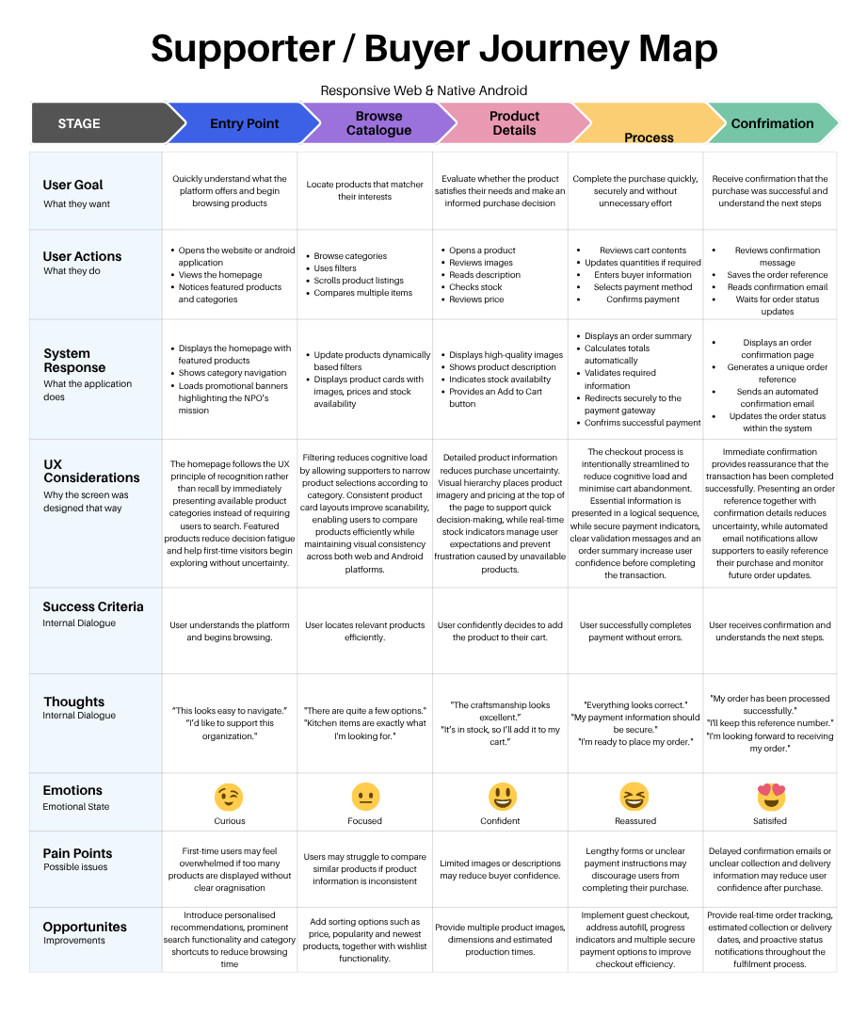

4.2.1 Journey Analysis
Entry Point
The Entry Point stage is designed to make it simple for new and returning users to comprehend the platform's goal and begin exploring the items available with little effort. Users may quickly find available choices without having to use their memory thanks to the homepage's highlighted goods, category navigation, and simple search feature. With this method, consumers may find handcrafted things while using less mental effort. The system responds by presenting organized categories of products, accompanied by promotional materials that articulate the non-profit organization's purpose. This helps users realize that each purchase aids the organization's objectives. The design enhances users' confidence and curiosity by providing a tidy interface with consistent navigation, hence reducing the likelihood of them leaving the platform due to confusion. Users' obvious knowledge of the platform and their advancement in looking for products indicate success at this point.
Browse Catalogue
In the Browse Catalogue step, users strive to locate things that best match their interests. Based on your chosen categories, the system dynamically filters products and presents product cards containing photographs, prices, and stock levels. By presenting data in a standardized layout that allows for rapid comparisons between goods, this design enhances usability. Visual homogeneity helps with scanning across both the web and Android versions of the platform, while category filtering reduces cognitive effort by limiting the number of items displayed at any one time. The browsing experience may be improved using advanced filtering, sorting, and wish list functionalities, even if customers may face issues due to misclassified items or insufficient filtering options. Users finding relevant items and confidently moving on to see comprehensive information determines success.
Product Details
Before purchasing a product, supporters may use the Product Details step to determine if it meets their needs. The system aids in informed decision-making by providing complete descriptions, several product photographs, pricing information, and real-time stock availability. By guaranteeing that users have access to all the product information they need before adding an item to their cart, these design components promote transparency and lessen uncertainty. A visual hierarchy highlights essential data, like pictures and prices, by strategically locating it in prominent locations for quick recognition by users. Precise descriptions and inventory indicators minimize potential problems like inadequate product information or out-of-stock items. At this point, the user's assurance in choosing a product and continuing to check out decides the outcome.
Process (Cart and Checkout)
The Process step is designed to help supporters finish their purchases quickly and securely. Users are directed via the checkout interface through a series of procedures that include reviewing their cart, entering their personal information, and paying. Before confirming the successful transaction, the system automatically computes totals, validates essential information, and directs users through the payment gateway in a secure manner. To maximize user confidence, these design decisions restrict unneeded form fields, show clear validation messages, and use secure payment indicators. Because online purchases are often abandoned at checkouts, simplifying the process and providing an order summary helps calm users before they complete their payment. When supporters finish their purchase without incident and with the assurance that their payment has been processed safely, success is attained.
Confirmation
The Confirmation stage clearly states the following actions and offers supporters comfort that their purchase was successful. After the money has been paid, the system displays an order confirmation page, creates a unique order reference, and automatically delivers a confirmation email. By providing immediate feedback that the transaction has been successfully processed, these components minimize uncertainty while also allowing fans to refer to their purchase if necessary. Further improvements, such as order tracking and estimated collection or delivery information, may increase transparency throughout the fulfillment process. At this point, fans feel assured that their order will proceed in the fulfillment process and understand that it has been received, which is how success is defined.
Section 4.3 NPO Director / Admin UX Journey Map
The experience of the employees with the online administration platform is the primary focus of the NPO Director/Admin's path. The aim of user experience (UX) is to make it easier to manage products, inventory, and customer orders by offering straightforward navigation, streamlined procedures, and quick system feedback.
Journey Map
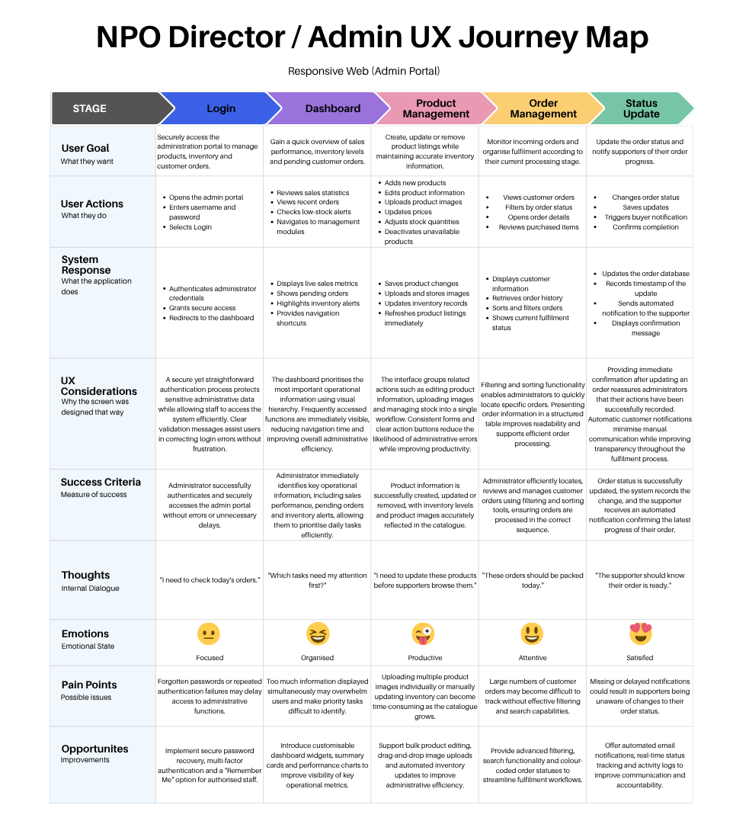
Section 4.3.1 Journey Analysis
Login
During the Login step, authorized people are granted safe access to the administration portal, protecting sensitive organizational data. Before being transported to the main dashboard, administrators confirm their identity by entering their login information. The login interface is designed to be straightforward, displaying only the required fields to access the system and giving validation messages for improper entries. This strategy reduces intricacy and enables personnel to begin their everyday duties right away. Without compromising usability, additional features such as multi-factor authentication and password recovery may improve security. When administrators access the system securely and without any authentication delays or mistakes, they are successful.
Dashboard
After logging in, administrators' primary workspace is the Dashboard, which immediately displays critical operational information. Staff can easily identify critical tasks without having to go through many screens since sales summaries, inventory notifications, and pending client orders are highlighted according to priority. Administrators can quickly access product or order management features and keep an eye on general business performance thanks to the system's ongoing presentation of relevant data. Information overload may be lessened, and effective decision-making may be promoted by arranging information into summary cards and widgets. When administrators can swiftly assess the organization's operational condition and determine their next actions, success is attained.
Product Management
Admins may keep a current and correct catalog of artisan products during the Product Management step. Employees can upload photos, change prices, update descriptions, and alter stock levels from a single management interface. Streamlining the workflow and reducing the chance of errors can be done by grouping similar actions. Ensuring that supporters always see accurate information when browsing the catalog, the system immediately refreshes product information after a modification is made. Additional advancements like mass editing, drag-and-drop picture uploads, and automatic stock management might increase administrative effectiveness even more. Success is attained when product data is reliable, coherent, and easily available to supporters.
Order Management
During the Order Management phase, administrators can examine, arrange, and handle supporter purchases during the whole fulfillment procedure. By using a structured table to show orders, employees may filter and search based on the status of an order, making it simple to find individual orders. By minimizing the possibility of ignoring outstanding requests and decreasing the amount of time it takes to process consumer requests, this firm achieves its goals. Operational accuracy and successful decision-making are both ensured by a clear display of client information, purchased goods, and fulfillment status. When administrators efficiently process client orders and keep precise order records during the whole fulfillment procedure, success is obtained.
Status Update
The Status Update phase ensures that administrators are informed of fulfillment operations while keeping supporters informed of the status of their purchases. Staff members update order statuses, such as "Received," "Packed," "Ready for Collection," or "Collected," after which the system logs the change and automatically notifies the supporter. Automated notifications reduce the need for manual communication, while rapid confirmation messages reassure administrators that their actions have been completed successfully. Accountability and transparency could be further increased by providing activity logs and real-time tracking. Success is defined by accurately documenting changes to orders and sending supporters quick alerts about the status of their orders.

Section 4.4 UX Design Insights
By aligning user interface selections with the demands of the two primary user groups, the journey maps demonstrate a user-centered design strategy. The experience focuses on product discovery, trust, and a streamlined checkout process for customers. The interface focuses on operational efficiency for administrators by offering simplified product management, automated status updates, and organized order processing. Visual hierarchy, consistency, feedback, recognition over recall, and error prevention are among the user experience principles employed during both travels to increase usability and aid in the effective completion of tasks.

Section 7.1 Domain Model Overview
The conceptual domain class diagram depicts the necessary business entities for the operation of the NPO e-commerce platform, as well as the relationships between them. In contrast to the database design, the domain model highlights the real items that are present in the pertinent region of interest and the interactions that enable the system's functionality. To ensure that fundamental business concepts are in line with user interactions, this model has been created using the user experiences of NPO Directors/Admins and Supporters/Buyers. Following the guidelines of conceptual UML modeling, the diagram excludes implementation-specific information including methods, primary keys, and foreign keys.
Section 7.2 Purpose of Core Domain Classes
Domain Class | Purpose Description
Category | Illustrates how handcrafted items are categorized into sensible categories like Bags, Kitchen, and Home Decor. Categories improve product organization and allow supporters to filter and browse products effectively.
Product | Showcases a handmade product from the nonprofit's sewing initiative. Detailed information, pricing, stock levels, and related photographs are included in every product to aid buying decisions.
Order | Indicates a supporter's completed purchase. Buyer data, payment details, the order's status, and the transaction's total amount are logged throughout the fulfillment process.
OrderItem | Represents an individual unit in a purchase order. It records the quantity purchased and the unit price at the time of sale, allowing multiple items to be linked to a single order.
AdminUser | Represents authorized personnel of the NPO who manage products, inventory, and customer orders through the administrative portal.

Section 7.3 Mapping UX Journeys to the Domain Model
UX Journey Stage | Domain Classes Involved | Reason
Entry Point | Category | Categories organize products for browsing
Browse Catalogue | Category, Product | Users browse products within categories
Product Details | Product | Product information supports purchasing decisions.
Process | Order, OrderItem | The system creates an order containing selected products.
Confirmation | Order | The completed order stores payment and status information.
Admin Login | AdminUser | Administrators authenticate to access management features.
Dashboard | AdminUser, Product, Order | Dashboard displays operational information.
Product Management | Product, Category | Administrators manage products and their categories.
Order Management | Order, OrderItem | Administrators review and process customer orders.
Status Update | Order | Order status changes are recorded and communicated to supporters.

Section 7.4 Conceptual Domain Class Diagram
UML Diagram:
Conceptual Domain Class Diagram
Category
name
description
Product
name
description
price
stockQuantity
photoUrls
isActive
OrderItem
quantity
unitPrice
Order
createdAt
status
buyerName
buyerContact
totalAmount
paymentReference
AdminUser
name
email
role
categorises
1
0..*
included in
1
0..*
contains
1..*
1
manages
0..*
1
manages
1
0..*

Section 7.5 Relationship Analysis
Category → Product (1 : 0..*)
A Category may contain multiple Products, but each Product is linked to only one category. This link promotes product categorization and allows supporters to navigate products using category-based filtering during the Supporter/Buyer experience.
Product → OrderItem (1 : 0..*)
A Product can appear in multiple OrderItems as various buyers may purchase the same product across different orders. This link enables the system to track every product purchase without reiterating product information.
Order → OrderItem (1 : 1..*)
An Order comprises one or more OrderItems, which denote the products purchased in a transaction. A composition relationship is used because an OrderItem cannot exist independently from its associated Order.
AdminUser → Order (1 : 0..*)
An AdminUser monitors different Orders throughout the fulfilment process by reviewing purchases, altering statuses, and managing the finalization of orders. This link emphasizes the responsibilities specified in the NPO Director/Admin UX experience.
Section 7.6 Domain Model Justification
Category
Products are categorized by the Category class, which makes navigation simpler and improves organization. The browsing experience described in the Supporter/Buyer journey is immediately improved by this.
Product
The Product class is the platform's primary business component. All the information necessary for fans to assess handmade products and make purchases is contained inside it.
Order
The Order class represents the completion of a purchase transaction and supports order tracking, fulfillment, and payment confirmation.
OrderItem
The Order Item class keeps track of the quantity and purchase price of each item, allowing for numerous products within a single order.
AdminUser
User Administrator Authorized personnel who are responsible for supervising customer orders, inventory, and goods using the administration portal.
Section 7.7 Summary
An overview of the fundamental entities required for the NPO e-commerce platform is provided by the class diagram for the conceptual domain. Every domain class is connected to the functions outlined in the user experience journeys for Supporter/Buyer and NPO Director/Admin, assuring synchronization between the system's conceptual design and the intended user experience. These classes and their relationships, taken together, provide the foundation for managing customer orders, handling products, and supporting administrative tasks.

Section 8 UML Design Class Diagram
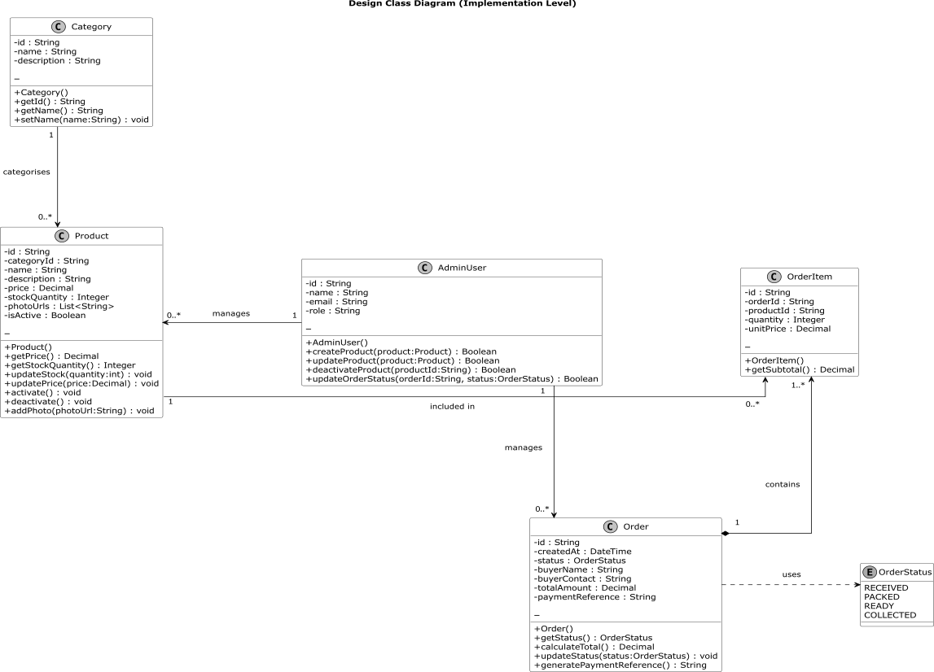

Section 9.1 Sequence and State Diagrams
Checkout, Payment and Stock Reservation
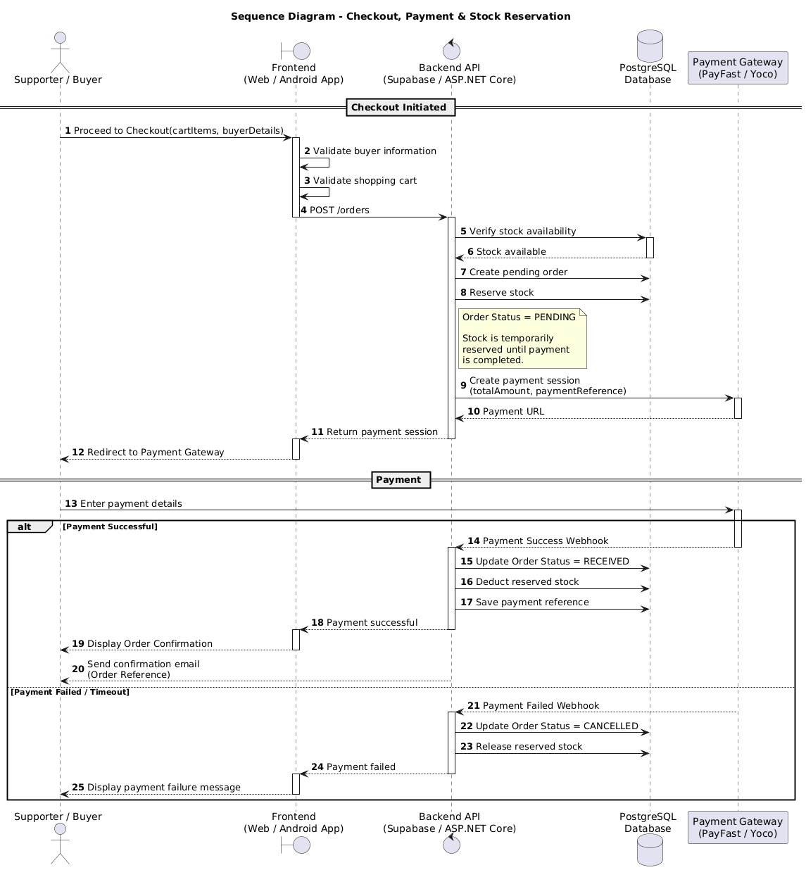
Section 9.2
Order Lifecycle
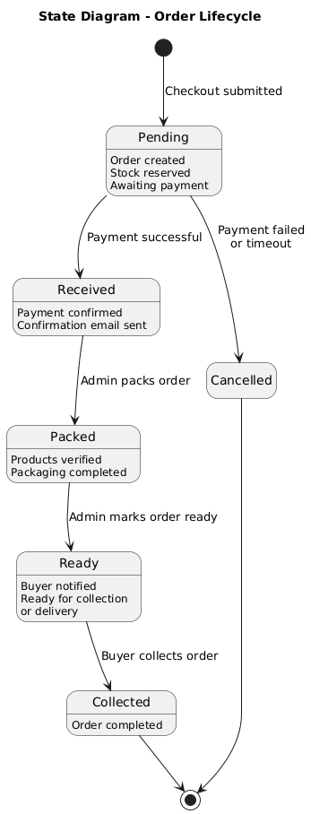
Reference List:
Baymard Institute (2024) Checkout Optimization: 5 Ways to Minimize Form Fields in Checkout. Available at: https://baymard.com/blog/checkout-flow-average-form-fields (Accessed: 10 August 2026).
Nielsen Norman Group (n.d.) Journey Mapping 101. Nielsen Norman Group. Available at: https://www.nngroup.com/articles/journey-mapping-101/ (Accessed: 10 August 2026).
Nielsen Norman Group (2024) 10 Usability Heuristics for User Interface Design. Nielsen Norman Group. Available at: https://www.nngroup.com/articles/ten-usability-heuristics/ (Accessed: 10 August 2026).
Object Management Group (2017) OMG Unified Modeling Language (OMG UML), Version 2.5.1. Available at: https://www.omg.org/spec/UML/2.5.1/ (Accessed: 10 August 2026).
OWASP Foundation (n.d.) Authentication Cheat Sheet. OWASP Cheat Sheet Series. Available at: https://cheatsheetseries.owasp.org/cheatsheets/Authentication_Cheat_Sheet.html (Accessed: 10 August 2026).
PlantUML (n.d.) Class Diagram. PlantUML. Available at: https://plantuml.com/class-diagram (Accessed: 10 August 2026).
PlantUML (n.d.) Sequence Diagram. PlantUML. Available at: https://plantuml.com/sequence-diagram (Accessed: 10 August 2026).
PlantUML (n.d.) State Diagram. PlantUML. Available at: https://plantuml.com/state-diagram (Accessed: 10 August 2026).
Supabase (n.d.) Database Webhooks. Supabase Documentation. Available at: https://supabase.com/docs/guides/database/webhooks (Accessed: 10 August 2026).

